NOME DO ALUNO(A) :
TURMA:

BIOLOGIA – ALBINO AZEVEDO - RNA

A figura representa, esquematicamente, um nucleotídeo. Esta molécula é de extrema importância para todos os seres vivos em razão dos diferentes papéis que desempenha no interior das células. Um dos papéis está relacionado à sua capacidade de formar diferentes polímeros no interior das células.

Analise as proposições em relação ao nucleotídeo.

I. Esta estrutura molecular é encontrada nas células de todos os seres vivos.
II. Existem cinco tipos de bases nitrogenadas que podem se ligar ao açúcar.
III. O açúcar, que se une ao fosfato e à base nitrogenada, tem em sua estrutura 5 carbonos.
IV. Os nucleotídeos são as unidades que formam os ácidos nucleicos.
V. Nucleotídeos se ligam por meio de suas bases nitrogenadas, e também estabelecem ligações entre o açúcar de um e com o fosfato do outro.

Assinale a alternativa correta.

a) Somente as afirmativas I, III e V são verdadeiras.
b) Somente as afirmativas I, II e IV são verdadeiras.
c) Somente as afirmativas II, III e IV são verdadeiras.
d) Somente as afirmativas I, II, III e V são verdadeiras.
e) Todas as afirmativas são verdadeiras.

A molécula de DNA armazena informação genômica que é transcrita e traduzida por mecanismos elegantes como os de transcrição e tradução. Entretanto, entre os distintos indivíduos biológicos construídos por mensagem contida no DNA, há uma singularidade biológica que se repete, mas se diferencia pelo modo como esta é organizada. Essa descrição corresponde à(s)

a) molécula de RNAr.
b) moléculas de RNAt.
c) bases nitrogenadas.
d) molécula de RNAm.
e) molécula de Dna.

Os ácidos nucleicos são polímeros que atuam no armazenamento, na transmissão e no uso da informação genética.
Com base na estrutura e função destes polímeros, assinale com V (verdadeiro) ou F (falso) as afirmações abaixo.

( ) Seus monômeros são denominados nucleotídeos.
( ) Seus monômeros estão unidos por meio de ligações fosfodiésteres.
( ) Suas bases nitrogenadas estão diretamente ligadas aos fosfatos.
( ) Suas bases nitrogenadas podem ser púricas ou pirimídicas.

A sequência correta de preenchimento dos parênteses, de cima para baixo, é

a) V – V – F – V.
b) V – F – V – F.
c) F – V – V – F.
d) F – F – V – V.
e) V – F – F – V.

(PUC-PR) No esquema abaixo sobre a estrutura do DNA, os números 1, 2 e 3 representam, respectivamente:
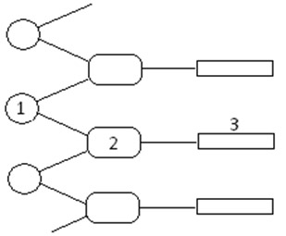
a) Base nitrogenada, desoxirribose e fosfato;
b) Base nitrogenada, fosfato e desoxirribose;
c) Fosfato, desoxirribose e base nitrogenada;
d) Fosfato, base nitrogenada e desoxirribose;
e) Desoxirribose, fosfato e base nitrogenada.

Assinale a alternativa que contém as palavras que completam a frase abaixo:

Existem cinco tipos principais de bases nitrogenadas: adenina, ______________, citosina, __________ e uracila. As duas primeiras possuem um duplo anel de átomos de carbono e derivam de uma substância chamada ____________, sendo, por isso, denominadas bases ______________.

a) Guanina, timina, purina, púricas.
b) Timina, guanina, pirimidina, púricas.
c) Timina, guanina, pirimidina, púricas.
d) Timina, guanina, púricas, pirimídicas.
e) Guanina, timina, purina, pirimidina.

MATEMÁTICA – JR. BRITO - TRIANGULO I - DEFINIÇÃO, CONDIÇÃO DE EXISTÊNCIA E CLASSIFICAÇÃO.

- No quadrilátero ABCD o valor de y – x é igual a
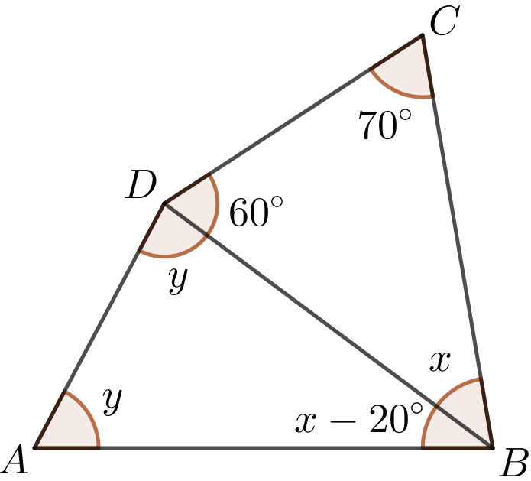
a) 2x
b) 2y

c) $\frac{x}{2}$

d) $\frac{y}{2}$

e) 3x

Os professores Jr. Brito, Oliveira e Sandro moram na mesma cidade. No sistema de coordenadas cartesianas, a casa do prof. Jr. Brito é representada pelo ponto J, a do prof. Oliveira pelo ponto O e a do prof. Sandro pelo ponto S. Sabemos que as distâncias, em linha reta, entre os pontos J e O são de 3 km, entre O e S são 10 km e entre J e S é 8 km. Com base nessas informações, podemos afirmar que a classificação, tanto quanto aos lados como aos ângulos, do triângulo formado pelos pontos J, O e S é, respectivamente

a) Escaleno e retângulo
b) Escaleno e acutângulo
c) Isósceles e retângulo
d) Equilátero e obtusângulo
e) Escaleno e obtusângulo

A figura abaixo mostra um triângulo, ou sinalizador de segurança, usado como um acessório de segurança dos automóveis. Ele é utilizado quando o automóvel, por algum motivo mecânico, para na estrada e fica impossibilitado de andar. Ele serva pra alertar os motoristas que tem um carro parado na estrada, para que esses possam diminuir a sua velocidade e desviá-lo e, com isso, evitar colisões e acidentes.
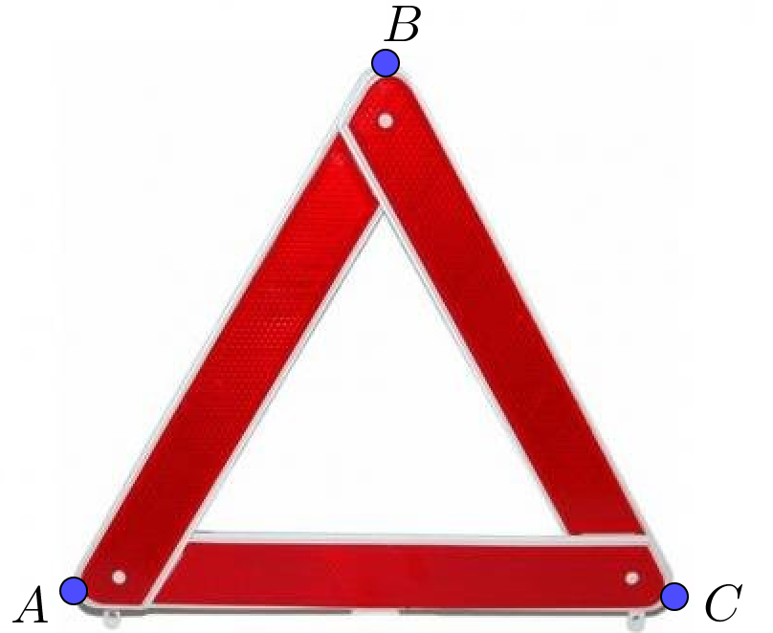

Sabendo que a triângulo ABC acima é equilátero e que $\overline{AB}=(2x+10)$ cm e $\overline{BC}=(x+35)$ cm. Então, podemos afirmar que $\overline{AC}$mede

a) 60 cm
b) 62 cm
c) 65 cm
d) 70 cm
e) 75 cm

A figura abaixo representa um triângulo obtusângulo.

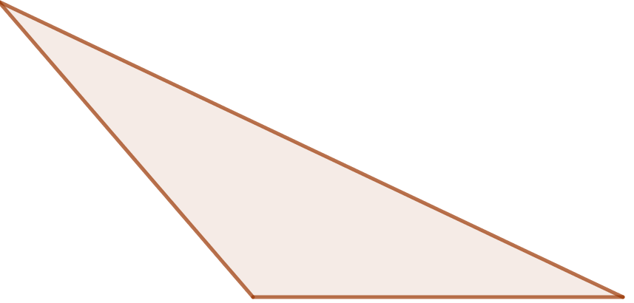

Qual das alternativas abaixo pode representar os lados desse triângulo?

a) 12, 12, 12
b) 9, 7, 3
c) 12, 10, 2
d) 7, 2, 10
e) 12, 5, 6

Na figura abaixo, os segmentos $\overline{AD}, \overline{BE}, \overline{CF}$e $\overline{EG}$ representam as ruas de um bairro.

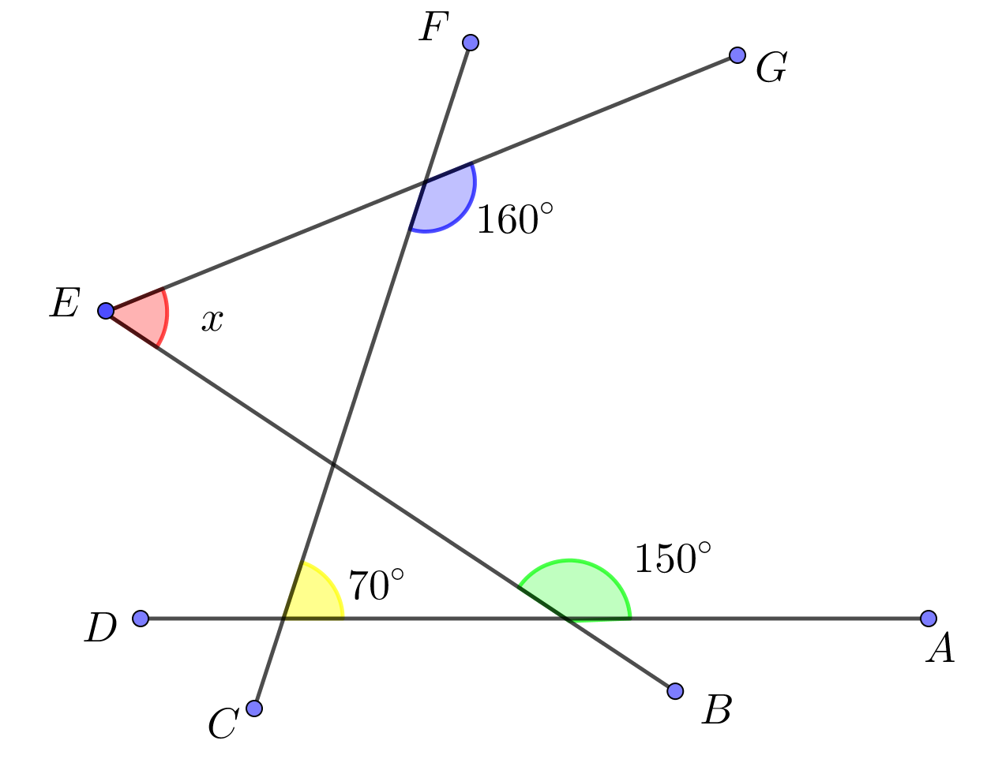

Com base nos seus conhecimentos, podemos afirmar que o valor do ângulo x é igual a

a) 50°
b) 60°
c) 70°
d) 80°
e) 90°

INGLÊS – ANNE PARENTE - ADVERBS OF FREQUENCY / OBJECT PRONOUNS

Six things I learned from riding in a Google self-driving car

1 - Human beings are terrible drivers.
We drink. We doze. We text. In the US, people die from automobile accidents every year. Traffic crashes are the primary cause of death worldwide for people aged 15-24, and during a crash, of drivers never even hit the brakes. We’re flawed organisms, barreling around at high speeds in vessels covered in glass, metal, distraction, and death. This is one of Google’s “moonshots” – to remove human error from a job which, for the past hundred years, has been entirely human.

2 - Google self-driving cars are timid.
The car we rode in did not strike me as dangerous. It drove slowly and deliberately, and I got the impression that it’s more likely to annoy other drivers than to harm them.
In the early versions they tested on closed courses, the vehicles were programmed to be highly aggressive. Apparently during these tests, which involved obstacle courses full of traffic cones and inflatable crash-test objects, there were a lot of screeching brakes, roaring engines and terrified interns.

3 - They’re cute.
Google’s new fleet was intentionally designed to look adorable. Our brains are hardwired to treat inanimate (or animate) objects with greater care, caution, and reverence when they resemble a living thing. By turning self-driving cars into an adorable Skynet Marshmallow Bumper Bots, Google hopes to spiritually disarm other drivers. I also suspect the cuteness is used to quell some of the road rage that might emerge from being stuck behind one of these things. They’re intended as moderate-distance couriers, not open-road warriors, so their max speed is miles per hour.

4 - It’s not done and it’s not perfect.
Some of the scenarios autonomous vehicles have the most trouble with are the same human beings have the most trouble with, such as traversing four-way stops or handling a yellow light.
The cars use a mixture of 3D laser-mapping, GPS, and radar to analyze and interpret their surroundings, and the latest versions are fully electric with a range of about miles.
Despite the advantages over a human being in certain scenarios, however, these cars still aren’t ready for the real world. They can’t drive in the snow or heavy rain, and there’s a variety of complex situations they do not process well, such as passing through a construction zone. Google is hoping that, eventually, the cars will be able to handle all of this as well (or better) than a human could.

5 - I want this technology to succeed, like… yesterday.
I’m biased. Earlier this year my mom had a stroke. It damaged the visual cortex of her brain, and her vision was impaired to the point that she’ll probably never drive again. This reduced her from a fully-functional, independent human being with a career and a buzzing social life into someone who is homebound, disabled, and powerless.
When discussing self-driving cars, people tend to ask many superficial questions. They ignore that of disabled people in the US still work. They ignore that of a car’s lifetime is spent parked. They ignore how this technology could transform the lives of the elderly, or eradicate the need for parking lots or garages or gas stations. They dismiss the entire concept because they don’t think a computer could ever be as good at merging on the freeway as they are. They ignore the great, big, beautiful picture: that this technology could make our lives so much better.

6 - It wasn’t an exhilarating ride, and that’s a good thing.
Riding in a self-driving car is not the cybernetic thrill ride one might expect. The car drives like a person, and after a few minutes you forget that you’re being driven autonomously. You forget that a robot is differentiating cars from pedestrians from mopeds from raccoons. You forget that millions of photons are being fired from a laser and interpreting, processing, and reacting to the hand signals of a cyclist. You forget that instead of an organic brain, which has had millions of years to evolve the cognitive ability to fumble its way through a four-way stop, you’re being piloted by an artificial one, which was birthed in less than a decade.
The unfortunate part of something this transformative is the inevitable, ardent stupidity which is going to erupt from the general public. Even if in a few years self-driving cars are proven to be ten times safer than human-operated cars, all it’s going to take is one tragic accident and the public is going to lose their minds. There will be outrage. There will be politicizing. There will be hashtags.
I say look at the bigger picture. All the self-driving cars currently on the road learn from one another, and possess 40 years of driving experience. And this technology is still in its infancy.
(Adapted from: <http://theoatmeal.com/blog/google_self_driving_car>. 21/08/2016.)

Com base na leitura do texto acima, pode-se inferir que:

a) a mãe do autor sofreu um acidente enquanto dirigia.
b) veículos autônomos causaram acidentes de trânsito mais trágicos do que carros dirigidos por homens.
c) acidentes de trânsito são a principal causa de morte de jovens em todo o mundo.
d) o novo carro autônomo do Google ainda é muito agressivo para ser usado em estradas abertas.
e) mais do que as pessoas que ainda estão no trabalho foram prejudicadas/ afetadas por acidentes de carro e são incapazes de dirigir.

CUL8R

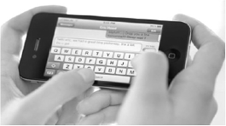

If you’re one of the 70% of cell-phone users who use text messaging, you know that CUL8R means “See you later.”
“Texting” is now the new way to talk (or “tlk”), especially for young people. But why is that?

IT’S A LOVE THING – There’s no doubt about it, text messages are for personal communication. Only of messages are work related, and the peak hours for texting are between and at night!
Most users (64%) say texting is a good way to send romantic messages – it’s easier to say “I love you” in a text message than in a phone call. Maybe that explains why more people now use texting to send Valentine’s Day messages.
UPSIDES AND DOWNSIDES – Generally, texting is cheaper than making phone calls. It’s also more direct, since you can send or get information without having to ask and answer polite “How are you?” questions. And it’s more discreet, too. No one can hear your “conversations,” and you can receive text messages almost anywhere – at work, in meetings, or in class. You can also use texting in noisy places like nightclubs, where using a cell phone is difficult.
A NEW LANGUAGE? – Because it’s quicker to “write” without apostrophes and vowels, texting has its own language. And it’s fun to use the symbols. There’s a best-selling dictionary (or “dxnre”) for texting called Wan2tlk?
Some people say that a texting encourages bad punctuation and spelling. On the other hand, more teens are writing than ever before. Now, that has to be a good thing.
(McCARTHY, M., McCARTEN, J. & SANDIFORD, H. Touchstone. Cambridge University Press. USA, 2005. Adaptado)

De acordo com o texto, o que significa o termo “TEXTING”?

a) É uma maneira de falar que os adolescentes costumam não ser compreendidos pelos pais.
b) É um livro ou outro pedaço de escrita, especialmente um relacionado à ciência ou ao aprendizado.
c) É uma maneira específica de escrever usada por pessoas que gostam de navegar na Internet.
d) É uma maneira especial de se comunicar escrevendo normalmente usando o telefone celular sem a necessidade de falar.
e) É uma maneira especial de se comunicar, um pouco mais cara que a usual.

The global mortality rate for children younger than 5 has dropped by nearly half since 1990, the United Nations said Tuesday in an annual report on progress aimed at ensuring child survival, but the decline still falls short of meeting the organization’s goal of a two-thirds reduction by next year. Without accelerated improvements in reducing health risks to young children, the report said, that goal will not be reached until 2026, 11 years behind schedule.
Nearly all of the countries with the highest mortality rates are in Africa, the report said, and two countries that are among the world’s most populous - India and Nigeria - account for nearly a third of all deaths among children younger than 5.
A collaboration of Unicef, other United Nations agencies and the World Bank, the report provides a barometer of health care and nutrition in every country. A child mortality rate can be a potent indicator of other elements in a country’s basic quality of life.
The report showed that the mortality rate for children younger than 5, the most vulnerable period, fell to 46 deaths per 1,000 live births last year, from 90 per 1,000 births in 1990. It also showed that the gap in mortality rates between the richest and poorest households had fallen in all regions over most of the past two decades, except for sub-Saharan Africa.
The report attributed much of the progress to broad interventions over the years against leading infectious diseases in some of the most impoverished regions, including immunizations and the use of insecticide-treated mosquito nets, as well improvements in health care to expectant mothers and in battling the effects of diarrhea and other dehydrating maladies that pose acute risks to the young.
“There has been dramatic and accelerating progress in reducing mortality among children, and the data prove that success is possible even for poorly resourced countries,” Dr. Mickey Chopra, the head of global health programs for Unicef, said in a statement about the report’s conclusions.
Geeta Rao Gupta, Unicef's deputy executive director, said, “The data clearly demonstrate that an infant’s chances of survival increase dramatically when their mother has sustained access to quality health care during pregnancy and delivery.”
Despite the advances, from 1990 and 2013, 223 million children worldwide died before their fifth birthday, a number that the report called “staggering.” In 2013, the report said, 6.3 million children younger than 5 died, 200,000 fewer than the year before. Nonetheless, that is still the equivalent of about 17,000 child deaths a day, largely attributable to preventable causes that include insufficient nutrition; complications during pregnancy, labor and delivery; pneumonia; diarrhea; and malaria.
While sub-Saharan Africa has reduced the under-5 mortality rate by 48 percent since 1990, the report said, the region still has the world’s highest rate: 92 deaths per 1,000 live births, nearly 15 times the average in the most affluent countries. Put another way, the report said, children born in Angola, which has the world’s highest rate - 167 deaths per 1,000 live births - are 84 times as likely to die before they turn 5 as children born in Luxembourg, with the lowest rate - two per 1,000.
The report noted that “a child’s risk of dying increases if she or he is born in a remote rural area, into a poor household or to a mother with no education.”
From: www.nytimes.com Sept. 16, 2014.

De acordo com o texto, a taxa de mortalidade infantil está entre os fatores responsáveis ​​pela mensuração do(a)

a) nível de educação.
b) crescimento econômico.
c) políticas democráticas.
d) qualidade de vida.
e) PIB.

Welcome to Madrid: City of Protests
Madrid (CNN) — “The people, united, will never be divided!” yells the crowd, angrily waving banners and placards. “To fight is the only way!” Dog-walkers, mothers with strollers, an pensioners carrying shopping bags join the crowd. These people on the sidewalk are no curious neighbors. Indeed, many of them are complete strangers to the family living on the fifth floor, but they are all here to protect Rocio from eviction – being forced to leave her property by legal process
Rocio and her son, now 17 and in high school, moved from Ecuador in 2003, when times were good and jobs plentiful in Spain. But then the global financial crisis hit, bringing Spain’s economy’ down, Rocio lost her two jobs – in a shop, and as a cleaner. For a while, Rocio got by on benefits but then those stopped too. She is an example of the crisis many Spaniards face as the country deals with the highest unemployment rate since the Civil War in the 1930s, and a recession entering its second year. “I can’t stand the thought of living on the streets with my san, but I have no idea where else to go”, she says.
Rocio’s story is echoed by others all over Spain. It is this fear that took many Spanish citizen to action. Many of those people who are outside the door of Rocio’s apartment block are supporter of “Stop Desahucios” (Stop Evictions), part of the Platform of People Affected by Mortgages (PAI – Plataforma de Afectados por la Hipoteca), a group that campaigns to prevent banks and authorities from eviction because of the country’s economic crisis. They accuse the banks and authorities o ‘real estate terrorism”.
There are also the mass marches of the 15-M movement – also known as the “Indignados”. Activist Dante Scherma, 24, says citizens were not used to speaking out on political issues. “The 15-M movement made people talk about social issues, and about politics in normal conversations - in cafés, restaurants, bars – where before they only talked about football or fashion.”
Back in Vicalvaro, the moment of truth has arrived, but the crowd – now shouting at the police, insisting they have to stop forcing families to leave their properties – appears to have had an impact. Lawyers from the PAH explain that Rocio will be able to stay – for a while, at least. For those working to stop Spain’s eviction epidemic, today has seen a small and temporary victory. For those demonstrating about cuts, corruption and lack of cash, the protests will go on.
Adaptado de: http://edition.cnn.com/2013/02/20/world/europe/madrid-city-of-protests/index.html
Segundo o texto, o movimento 15-M fez

a) A vida dos espanhóis perder sua importância.
b) Os cidadãos da Espanha ficarem mais interessados ​​em questões sociais.
c) Os espanhóis falarem mais sobre futebol e moda.
d) As pessoas irem a cafés, restaurantes e bares.
e) os espanhóis aceitarem despejos.

Empirically Based Leadership

A significant area of interest within the US Army empirical literature on leadership is emotional Intelligence (EI), which in recent years has been the focus of considerable attention in relationship to leadership efficacy. Emotional intelligence Involves an awareness of one’s own emotions as well as the ability to control them, social awareness of others and their emotions, and the capacity to understand and manage relationship and social networks.
In understanding others’ emotions, an important contributing factor to the success of the more effective military officers is their ability to empathize with their subordinates. In discussing empathy, EM (Field Manual) 6-22 defines it as “the ability to see something from another person’s point of view, to identify with and enter into another person’s feelings and emotions”. Empathy is not typically a quality that most soldiers would readily identify as an essential characteristic to effective leadership or necessary to producing positive organizational outcomes, but it is an important quality for competent leadership, especially as it relates to EI.
Adaptado de McDONALD. Sean P. Military Review, Jan-Feb, 2013.
De acordo com o texto, podemos afirmar que

a) A empatia faz parte da inteligência emocional.
b) A inteligência emocional não inclui empatia.
c) A inteligência emocional é a capacidade de evitar a empatia.
d) O exército dos EUA quer que os soldados escondam sentimentos.
e) O Exército dos EUA quer que os líderes do Exército controlem os sentimentos dos seus subordinados.

FÍSICA – SÍLVIO MESQUITA - MOVIMENTO UNIFORMEMENTE VARIADO (MUV)

- A ampliação da rede de trem metropolitano (metrô) na cidade de São Paulo, visa reduzir o caos do congestionamento urbano, melhorar o transporte coletivo da população e contribuir com a melhoria da qualidade do ar.
Considere uma composição do trem em movimento entre duas estações seguidas, partindo do repouso na Estação Tiradentes e parando na Estação Luz. O esboço gráfico velocidade × tempo que melhor representa o movimento é:

a)
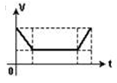
b)
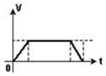

c)
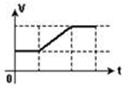

d)
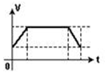

e)
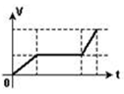

Um móvel em movimento retilíneo tem velocidade escalar variando com o tempo , de acordo com o gráfico.
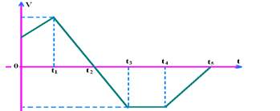

Podemos afirmar corretamente que entre os instantes:

a) 0 e t1o movimento é retrógrado acelerado.
b) t1e t2o movimento é progressivo acelerado.
c) t2e t3o movimento é retrógrado acelerado.
d)) t3e t4o móvel está parado.
e) t4e t5o movimento é progressivo retardado.

Em uma prova de 100 m rasos, o desempenho típico de um corredor padrão é representado pelo gráfico a seguir:
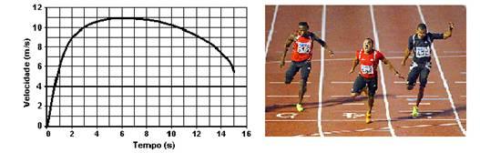
Em que intervalo de tempo o corredor apresenta ACELERAÇÃO máxima?

a) Entre 0 e 1 segundo.
b) Entre 1 e 5 segundos.
c) Entre 5 e 8 segundos.
d) Entre 8 e 11 segundos.
e) Entre 9 e 15 segundos.

A seguir, apresentamos um quadro para a comparação da aceleração de alguns veículos. Para todos os casos, o teste foi realizado com os veículos acelerando de 0 a 100 km/h. Observe o tempo necessário para que todos tenham a mesma variação de velocidade:
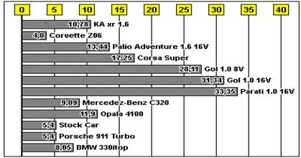
Tomando como referência o gráfico apresentado, marque a alternativa que indica corretamente o veículo que possui maior aceleração e indique qual a relação, aproximada, entre a sua aceleração e a do veículo de menor aceleração.

a) Parati e 8 vezes maior.
b) Parati e 8 vezes menor.
c) Corvette e 8 vezes maior.
d) Corvette e 8 vezes menor.
e) Corvette e 10 vezes maior.

O gráfico representa a velocidade em função do tempo de uma pequena esfera em movimento retilíneo. Em t = 0, a esfera se encontra na origem da trajetória.
Qual das alternativas seguintes apresenta corretamente os gráficos da aceleração (a) em função do tempo e do espaço (s) em função do tempo (t)?
a)
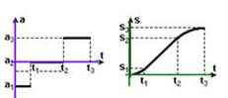

b)
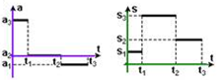

c)
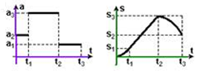

d)
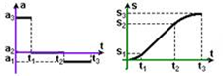

e)
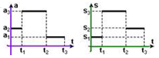

QUÍMICA – HENRIQUE NARDIE - NÚMERO QUANTICO.

- Um elétron localiza-se na camada “2” e subnível “p” quando apresenta os seguintes valores de números quânticos:

a) n = 4 e ℓ= 0
b) n = 2 e ℓ= 1
c) n = 2 e ℓ= 2
d) n = 3 e ℓ= 1
e) n = 2 e ℓ= 0

Considere três átomos A, B e C. Os átomos A e C são isótopos, B e C são isóbaros e A e B sãoisótonos. Sabendo-se que A tem 20 prótons e número de massa 41 e que o átomo C tem 22 nêutrons, os números quânticos do elétron mais energético do átomo B são:

a) n = 3; ℓ = 0, m_{ℓ}= 2; s = -1/2
b) n = 3; ℓ = 2, m_{ℓ}= -2; s = -1/2
c) n = 3; ℓ = 2, m_{ℓ}= 0; s = -1/2
d) n = 3; ℓ = 2, m_{ℓ}= -1; s = 1/2
e) n = 4; ℓ = 0, m_{ℓ}= 0; s = -1/2

De acordo com o modelo atômico atual, a disposição dos elétrons em torno do núcleo ocorre em diferentes estados energéticos, os quais são caracterizados pelo número quântico principal e secundário. Para o elétron mais energético do átomo de escândio no estado fundamental, os números quânticos principal e secundário são, respectivamente: (Z = 21)

a) 3 e 0
b) 3 e 2
c) 4 e 0
d) 4 e 2

A principal aplicação do bromo é a produção de brometo de etileno, que é utilizado em combustíveis para motores com o intuito de evitar a acumulação de chumbo no interior dos cilindros. Considerando que o número atômico do bromo é 35, afirma-se que ele possui:

I. O número quântico principal igual a 4.
II. 3 orbitais completos.
III. 5 elétrons no nível de valência.
IV. O número quântico magnético igual a 0.
V. 5 elétrons na última camada, com número quântico azimutal igual a 1.

Estão corretas apenas as afirmativas

a) I e IV.
b) I, II e V.
c) III, IV e V.
d) I, II, IV e V.

A configuração eletrônica do átomo de Selênio no estado fundamental é: 1s² 2s² 2p⁶ 3s² 3p⁶ 4s² 3d¹⁰ 4p⁴. Considerando o subnível mais energético desse átomo, marque a alternativa que contém os valores dos números quânticos para o último elétron desse subnível.

a) 2, 0, +1 e +1/2.
b) 2, 1, -1 e +1/2.
c) 4, 1, -1 e +1/2
d) 4, 0, -1 e +1/2.
e) 0, -1, +1/2, 2.

